Assignment #2: Career Development.

Written By: Eric Webb

Professor: Yair Levy, Ph.D.

Class: ISEC-690, Fall 2020.

Due: October 11, 2020.

Table of Contents

Self-Reflection 1

Handshake Profile………………………………………………………………………..………………………………………………………….2

Signed Resume and Interview 3

Certificate of Authorship 4

Self-Reflection:

In this narrative, I was asked to do a resume building session, handshake set up informational, and a mock interview through Nova Southeastern’ s Career Development office.

My experience with them wasn’t just warm and pleasant but was also very informative.

Resume Building:

In the resume building session, I learned a lot about my resume especially where there is room for improvement. Some small examples are making properties less bulky or extending dates all the way to the right for better visual effects.

* In this resume building session, I learned that no resume is perfect and there is always room for improvement.

Handshake Building:

In the handshake building session, we went over how to create and market yourself on the handshake website. This included putting information about my previous work and education.

* In this handshake building session, I learned that no single platform is the right answer and that although having a LinkedIn is good, it can also be help to have other professional platforms as to “Keep up with the Jones.”

Mock Interview:

In the Mock Interview, we went over popular communication exercises that candidates typically face in a professional interview. This is very helpful when preparing your self to interview for a role of a lifetime.

* In this mock interview session, I learned being technically literate is not enough to make it in a technical filed, you must also be able to communicate and work in a team setting.

**Handshake Profile.**

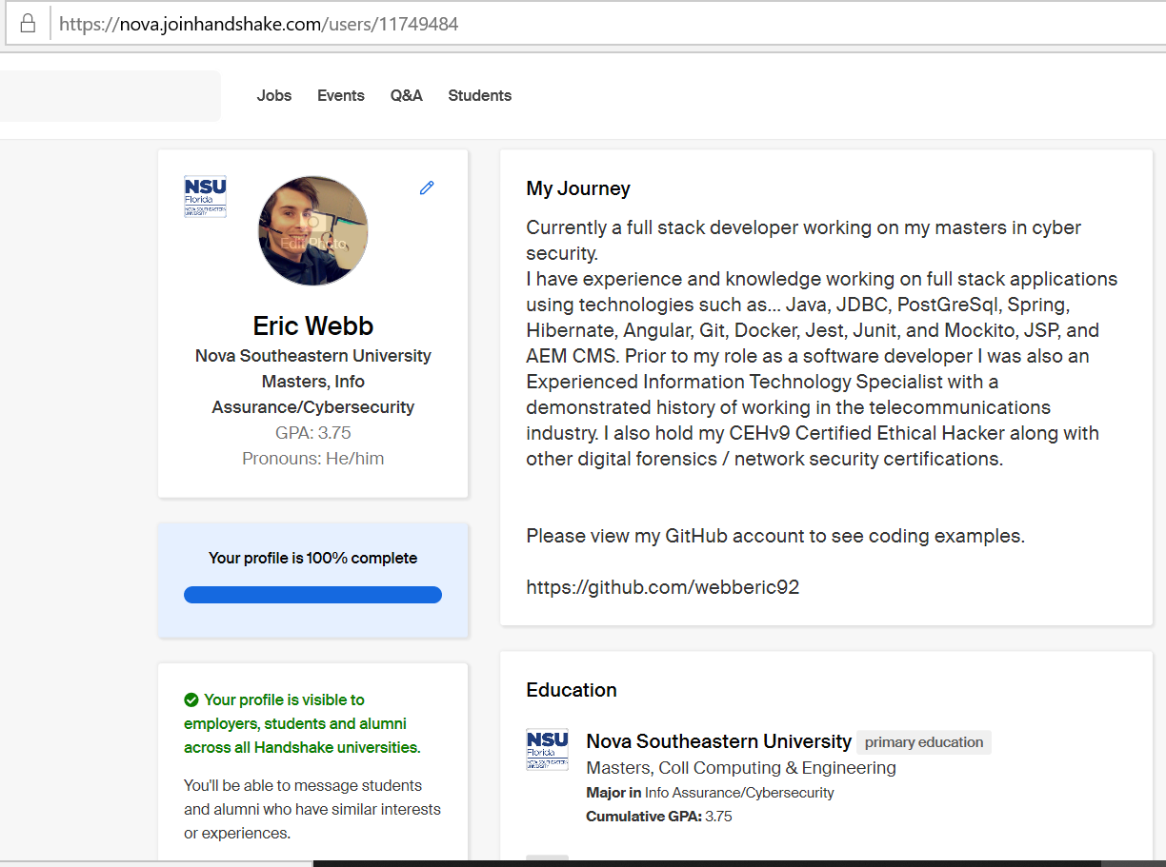

**Signed Resume and Interview.**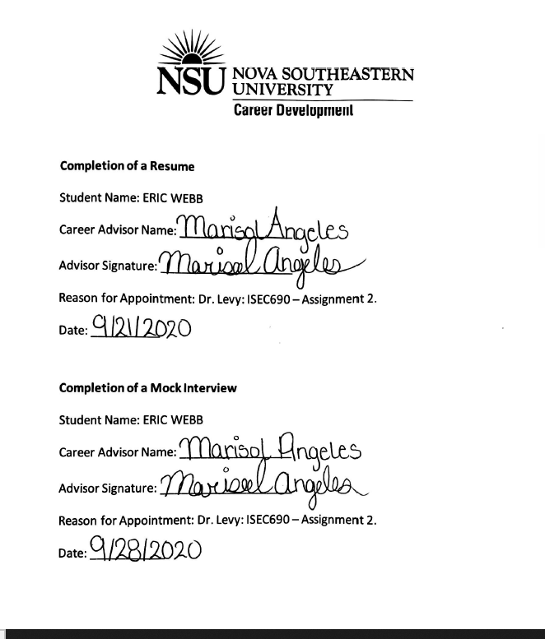



Certification of Authorship of Assignment

Submitted to (Professor’s Name): Yair Levy, Ph.D.

Class: ISEC690

Students’ Names: Eric Webb

Date of Assignment: October 11, 2020.

Title of Assignment: Assignment #2, Career Development.

Certification of Authorship: By submitting this document we certify that we are the authors of this paper and that any assistance we received in its preparation is fully acknowledged and disclosed in the paper. We have also cited any sources from which we used data, ideas or words, either quoted directly or paraphrased. We also certify that this paper was prepared by us specifically for this course.

Students’ Signatures: Eric Webb